curNC Software Requirements Specification and Design Document
Introduction
Created in 2009, Bitcoin’s subsequent popularity caused the field of cryptocurrencies to rise to fame, becoming a common topic of discussion and trade for news outlets and speculators. These decentralized currencies have huge worth in the modern trading market with an economy holding the equivalent to billions of US dollars, but for people interested in this relatively new field, the massive amount of information surrounding it can be difficult to maneuver. As the market currently consists of over 1600 separate currencies each with their own method of distribution and knowledge base, an all-encompassing application that helps users learn the ropes and evaluate the value of each could be very helpful, leading to the creation of curNC, an application devoted to all things cryptocurrency.
curNC aims to first inform potential investors with the knowledge that entering this market requires, secondarily provide users with an overview of the entire cryptocurrency market through evaluating each in terms of current non-virtual value as well as against other cryptocurrencies, thirdly provide the market history of each cryptocurrency, and finally aims to build a communal view of the market through user interaction. With access to an overview of the field, the history and the means of distribution for each currency, curNC will give users all the information they need to learn about and then further participate in this enormous market. Further, signing up for a curNC account will allow users to favorite or suggest avoiding currencies and voice their opinions through comments, which lets them follow their changing value over time, save them for later study and see other curNC users’ opinions of each individual currency. These comments will hold weight based on community approval through the form of an upvote and downvote system, meaning that community approved comments will be recognized as such and nonfactual or unwanted comments will be able to be looked over.

Architecture
As a web application, curNC will require a system with both a client side and a server side, the client side being the application that users see and the server side providing the data required for the application to run, like accounts and information on each cryptocurrency. Through the application, users will be able to sign up for and manage personal accounts that are stored in curNC’s database. The modifiable user accounts, recommendations, and comments will also require database interaction. The major inputs of the system will be the scraped data for the prices of cryptocurrencies, the user accounts’ email and password, the recommendations and oppositions that users can leave on a cryptocurrency, the comments that each user can input on each cryptocurrency’s page and the upvotes and downvotes that those comments receive. The outputs of the system are the list of cryptocurrencies and their prices, the cryptocurrencies’ number of recommendations and disapprovals, the comments that other users have left on the cryptocurrency’s pages and their upvotes and downvotes, and the introductory page.
This application will be built using JavaScript, CSS, MySQL and Node.js. JavaScript and CSS will be utilized to create the front end webpage for user interaction, as well as providing a way to track the prices of each cryptocurrency. MySQL will be used for the application’s database, and will interact with the webpage in order to store and retrieve data like user preferences. Node.js will be used to scrape data from the websites that each cryptocurrency uses, allowing for displayed prices to be updated regularly.

Use Cases
Administrative User- Use Cases
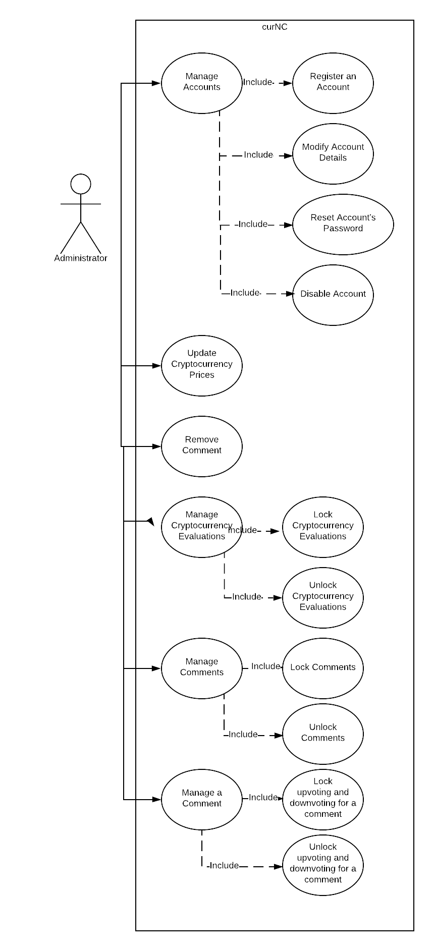
Public User- Use Cases
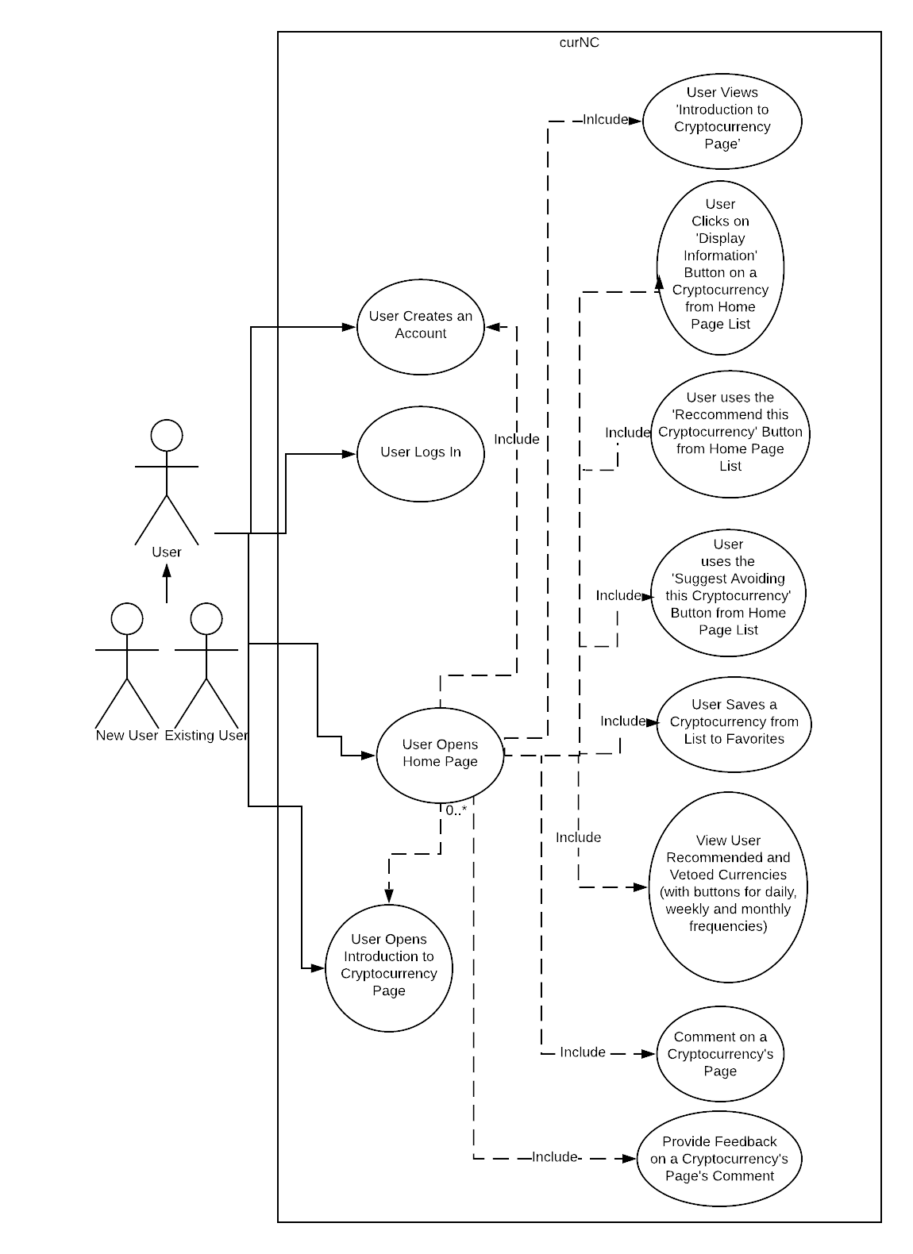

Administrator Scenarios:
- Manage Accounts: The administrator is shown a list of accounts’ emails and passwords and is given the options to register a new account, modify the specific accounts’ details, reset each account’s password and disable the account.
  - Should the administrator select “Register an Account,” they are shown the register account screen that is accessible by the homepage, where they can enter an email and password to generate a new account
  - Should the administrator select “Modify Account Details,” they can select an account from the shown list and change both its email and password from a new screen
  - Should the administrator select “Reset Account’s Password,” an email containing a link to a webpage for changing the account’s password is sent to the holder of the account
  - Should the administrator select “Disable Account,” the account chosen will be locked to the user and the comments left by the account will be deleted from the cryptocurrencies’ pages.
- Update Cryptocurrency Prices: The administrator is shown all of the cryptocurrencies’ information in a list and can add new prices to each that have been scraped from the internet, as well as modify previous entries for each.
- Remove a Comment: The administrator is shown the homepage list of cryptocurrencies and can select a page to open. From there, the comments shown will have an option of deletion next to each comment.
- Manage Cryptocurrency Evaluations: The upvotes and downvotes that each cryptocurrency has received are shown next to the list of cryptocurrencies and the administrator is given the option of locking, unlocking, and removing user feedback on each.
- Manage Comments: The administrator can, from a cryptocurrency’s page, lock and unlock the abilities for users to comment on the page through a shown button.
- Manage a Comment: The administrator, on a cryptocurrency’s page, can view the comments that have been posted. From the comment, the administrator will be able to lock and unlock the abilities of users to provide feedback.
Public User Scenarios:
- User Creates an Account: User enters an email into a textbox on a newly generated page, which is then checked for in the database. The user then creates and verfifies a password for their account, which is then stored in the database. After being notified of their account’s creation, they are logged into their account and shown the homepage again.
  - Should the account already exists or the email is invalid, the user is told to enter a new email through a notification
- User Logs In: From a shown login page, the user enters their account details and is shown the homepage.
  - Should the email not be attached to a made account or their password to not match the one stored in the database, the user is notified that their login credentials are incorrect.
- User Opens Home Page: The user is shown the list of cryptocurrencies and their prices, with the options of opening the Create Account page, Log In to an already created account, and view the Introduction to Cryptocurrency Page.
  - Should the user click on the “Display Information” button the a cryptocurrency, they are shown a new page that shows the cost history, number of recommendations, vetoes and comments for the selected cryptocurrency, loaded from the database.
  - Should the user use the “Recommend this Cryptocurrency” button from the homepage list, the database increments the number of recommendations for that cryptocurrency and shows the user that they’ve recommended this cryptocurrency. The option of recommending avoiding the cryptocurrency will negate this effect.
  - Should the user use the “Recommend Avoiding this Cryptocurrency” button from the homepage list, the database increments the number of recommendations to avoid that cryptocurrency and shows the user that they’ve recommended avoiding this cryptocurrency. The option of recommending avoiding the cryptocurrency will negate this effect.
  - Should the user save a cryptocurrency from the home page list, the database stores the cryptocurrency into the user’s list of favorites, and this list will be shown first on the home page list.
  - Should the user view the User Recommended and Vetoed Currencies, they will be given the option to view daily, weekly and monthly frequencies. From there, a new page will be opened that displays the most recommended and most vetoed currencies at the top of the list, with the rest of the cryptocurrencies following.
  - Should the user comment on a cryptocurrency’s page, there will be a textbox that is opened where they can enter their desired comment
  - Should the user want to provide feedback on a cryptocurrency’s page’s comment, they will be able to select upvoting or downvoting the comment from buttons displayed next to them.
- User Opens the Introduction to Cryptocurrency Page: The user is shown text that explains the basics of the field cryptocurrency to the user, having definitions for concepts such as blockchain and showing how cryptocurrencies are generated.

Structural Design
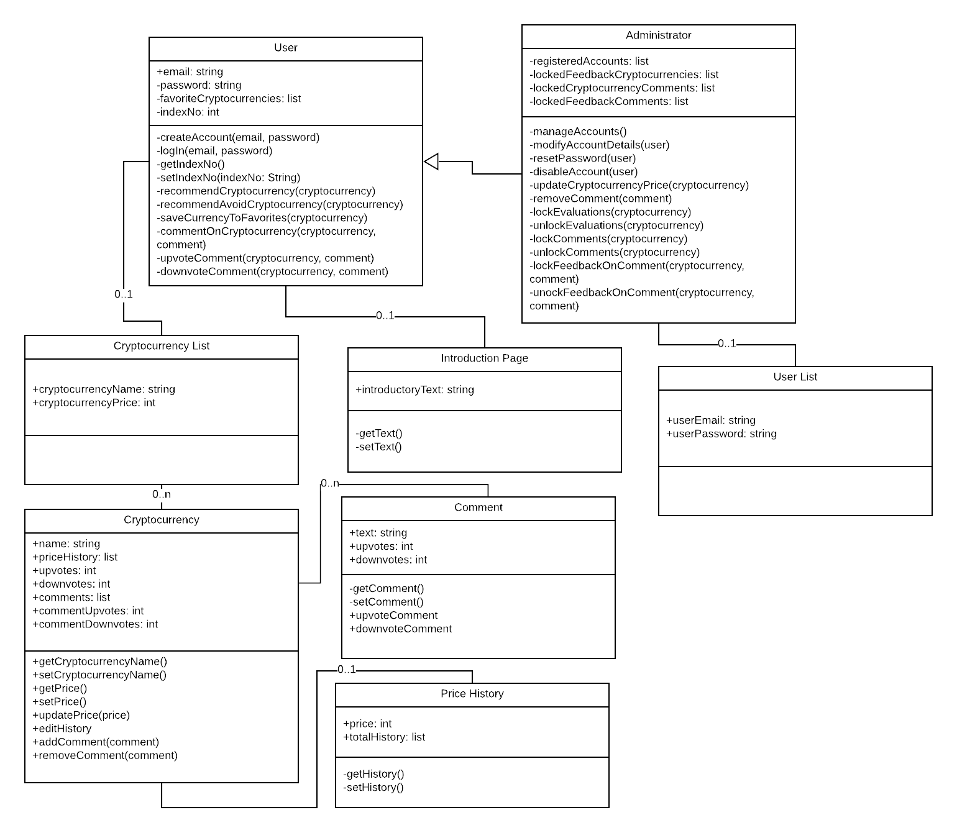

User Interface Design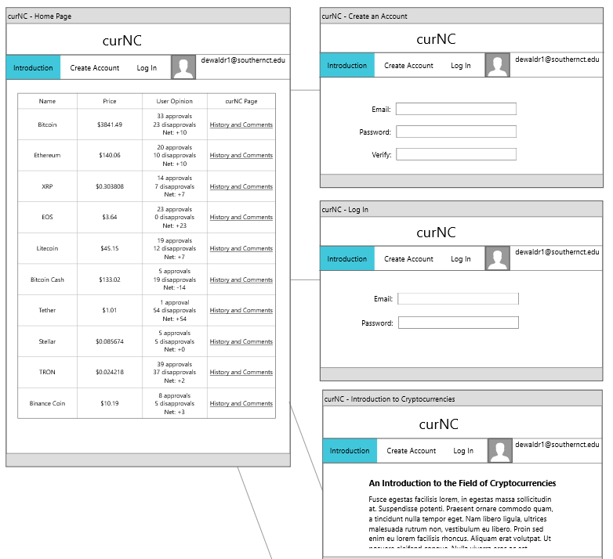
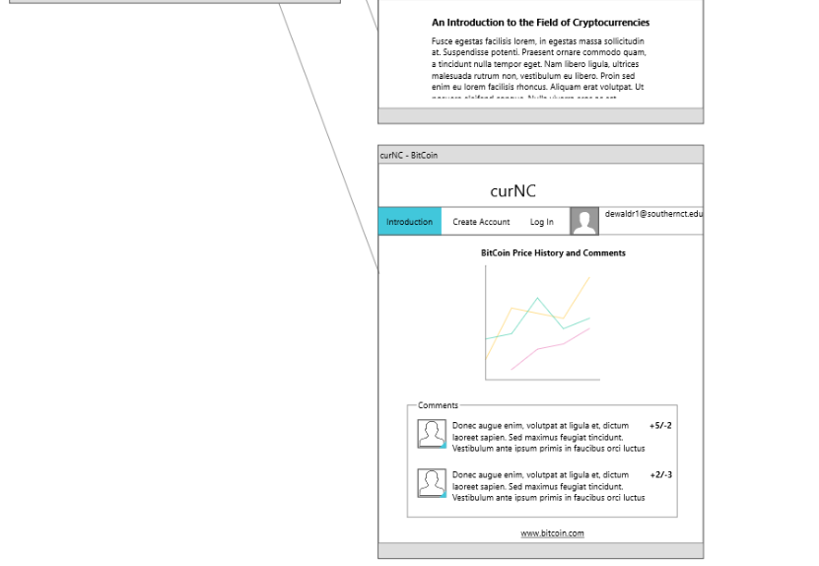

Detailed Workplan

